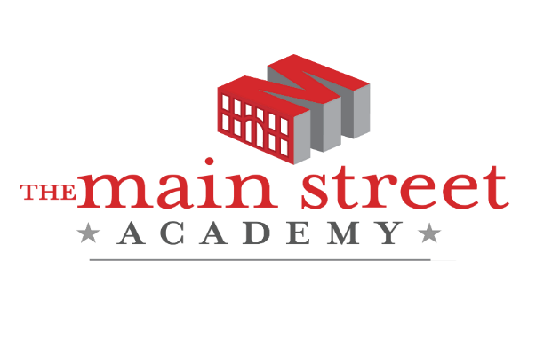

TMSA SUMMER SCHOOL 2021

Elementary ​Summer School (Grades K-5) is an opportunity for elementary students to receive targeted support in reading and/or mathematics in a face-to-face setting.

Middle School ​Summer School is an opportunity for middle school students to clear incompletes from 2020-2021 or recover credits during the time between school years. The summer sessions are condensed versions of content provided during the school year, and students must have their course requests validated by their counselor before being enrolled.
For summer 2021, students who have previously failed a year-long World Language course have the opportunity to retake the course for free through Fulton Virtual School. Students may take up to two credits at no cost. In addition, students who have Incompletes, WFs or F's from 2020-2021 will attend summer school at no cost in order to clear the incompletes, WFs, or F's.

IMPORTANT DATES

Pre-Planning | June 1, 2021
Summer School | June 2 – June 30
Elementary (K-5) | Face-to-Face  8 am – 12 pm
Middle (6 -8) | Virtual (On- Campus)  8 am – 12 pm

2681 Lakeshore Drive
College Park, GA 30331
404.768.0081 | www.tmsa.org

