Re Opening Committee Meeting
02/17/21
(5PM via Zoom)

Mission: At The Main Street Academy, all students will receive a challenging and enriching education from a dedicated and student-focused staff in partnership with highly-involved parents. Students will leave The Main Street Academy with high expectations of themselves as they prepare for further education and become contributing members of their diverse communities.
1. Attendance
- 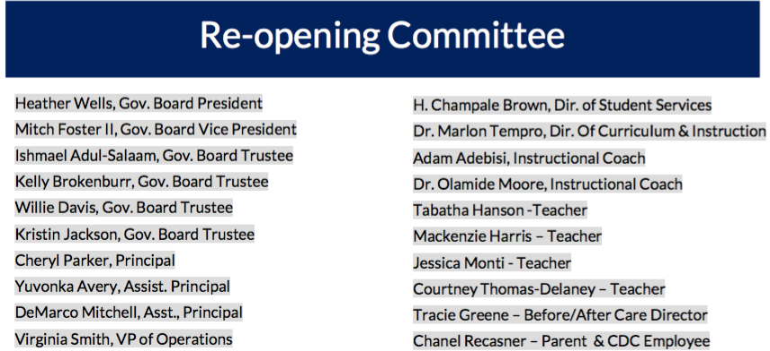

- Approval of the Minutes
Summary Brief: The Reopening Committee would like to report that as of our last Emergency Board Meeting new COVID cases have dropped in our cache area in South Fulton Cities. The cases per 100,000 are still identified as Substantial Spread (> 100/100,000). At this level the committees continues to monitor community spread to determine the safest and the best time to return to F2F learning. The CDC Guidelines, government health officials, GaDOE and FCS continue to be our primary source of information. In this environment we continue to recommend that students be delivered the highest quality of instruction using the virtual model. Additionally, we continue to monitor vaccine distribution for educators and COVID testing opportunities to help support a safe learning and working environment. We are exploring opportunities to test in our school as long as we can do so lawfully and safely. We have set action plans in order to make determinations as when to reenter safely and to best support our students with the greatest needs. We also seek ways to support our community by providing resources as well as support our teaching staff by listening to their reopening concerns and directing their personal concerns as needed. Finally we continue to meet on Wednesdays at 5pm via Zoom to collaborate on reopening strategies within our framework.

- Community Questions
- Epidemiology Report- South Fulton County Cities

South Fulton Cities  (TMSA Catchment Area) | Number of new cases per 100,000 within the last 14 days
 | August 11, 2020 | December 18, 2020 | February 23,2021
College park | 331.5 | 317.1 | 295
East Point | 357.4 | 463.2 | 297
Fairburn | 421.5 | 428.3 | 387.5
Hapeville | 334.3 | 425.5 | 273.5
Palmetto | 205.9 | 366 | 343.1
South Fulton | 307 | 450 | 334.3
Union City | 357.8 | 682 | 453.2
Average | 330.8 | 689 | 340.5

Primary Indicator |  | 12/29/20 | 1/8/21 | 1/12/21 | 1/19/21 | 1/26/21 | 2/2/21 | 2/9/21 | 2/16/21 | 2/23/21
 | Number of new cases per 100,000 within the last 14 days | 584.3 | 562.4 | 692.1 | 872.6 | 866.2 | 762.2 | 643.7 | 478.9 |  | 340.5
 | plus /minus |  | -3.7 | 23.1 | 26.1 | -0.7 | -12.0 | -15.5 | -25.6 | -28.9

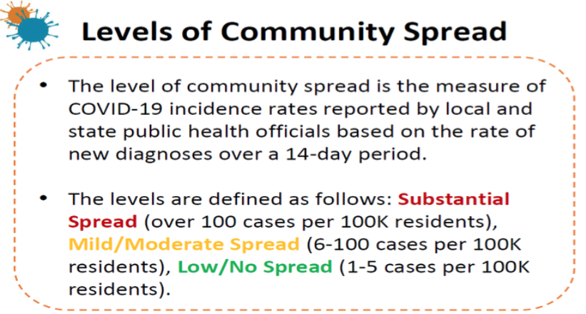
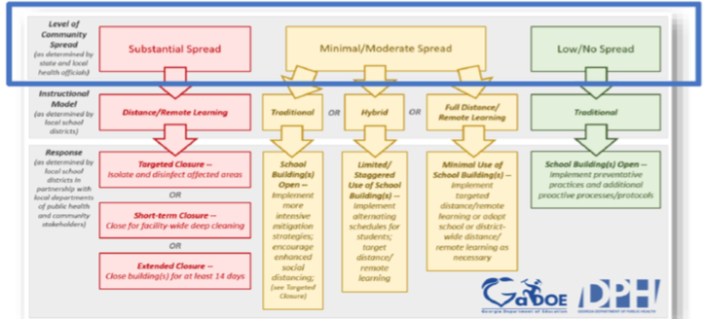

- School Reports
- -Health
-Weekly Report
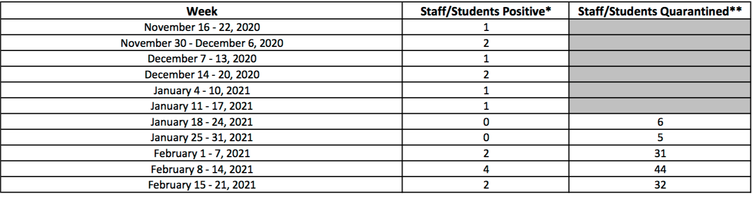

-Mitigation Guidelines (Updated?)

- -Academics (School Base/ Virtual)
Learning Model Proposal
- -Successes /Opportunities
- Next Steps
- Possible Board Recommendations
Motion to start back the hybrid model at the beginning of Quarter 4, March 1X, 2021 provided that the community spread numbers are below 100/100,000 , <50/100,000 to return to F2F. The virtual learning option will remain for the remainder of the 20/21SY.

