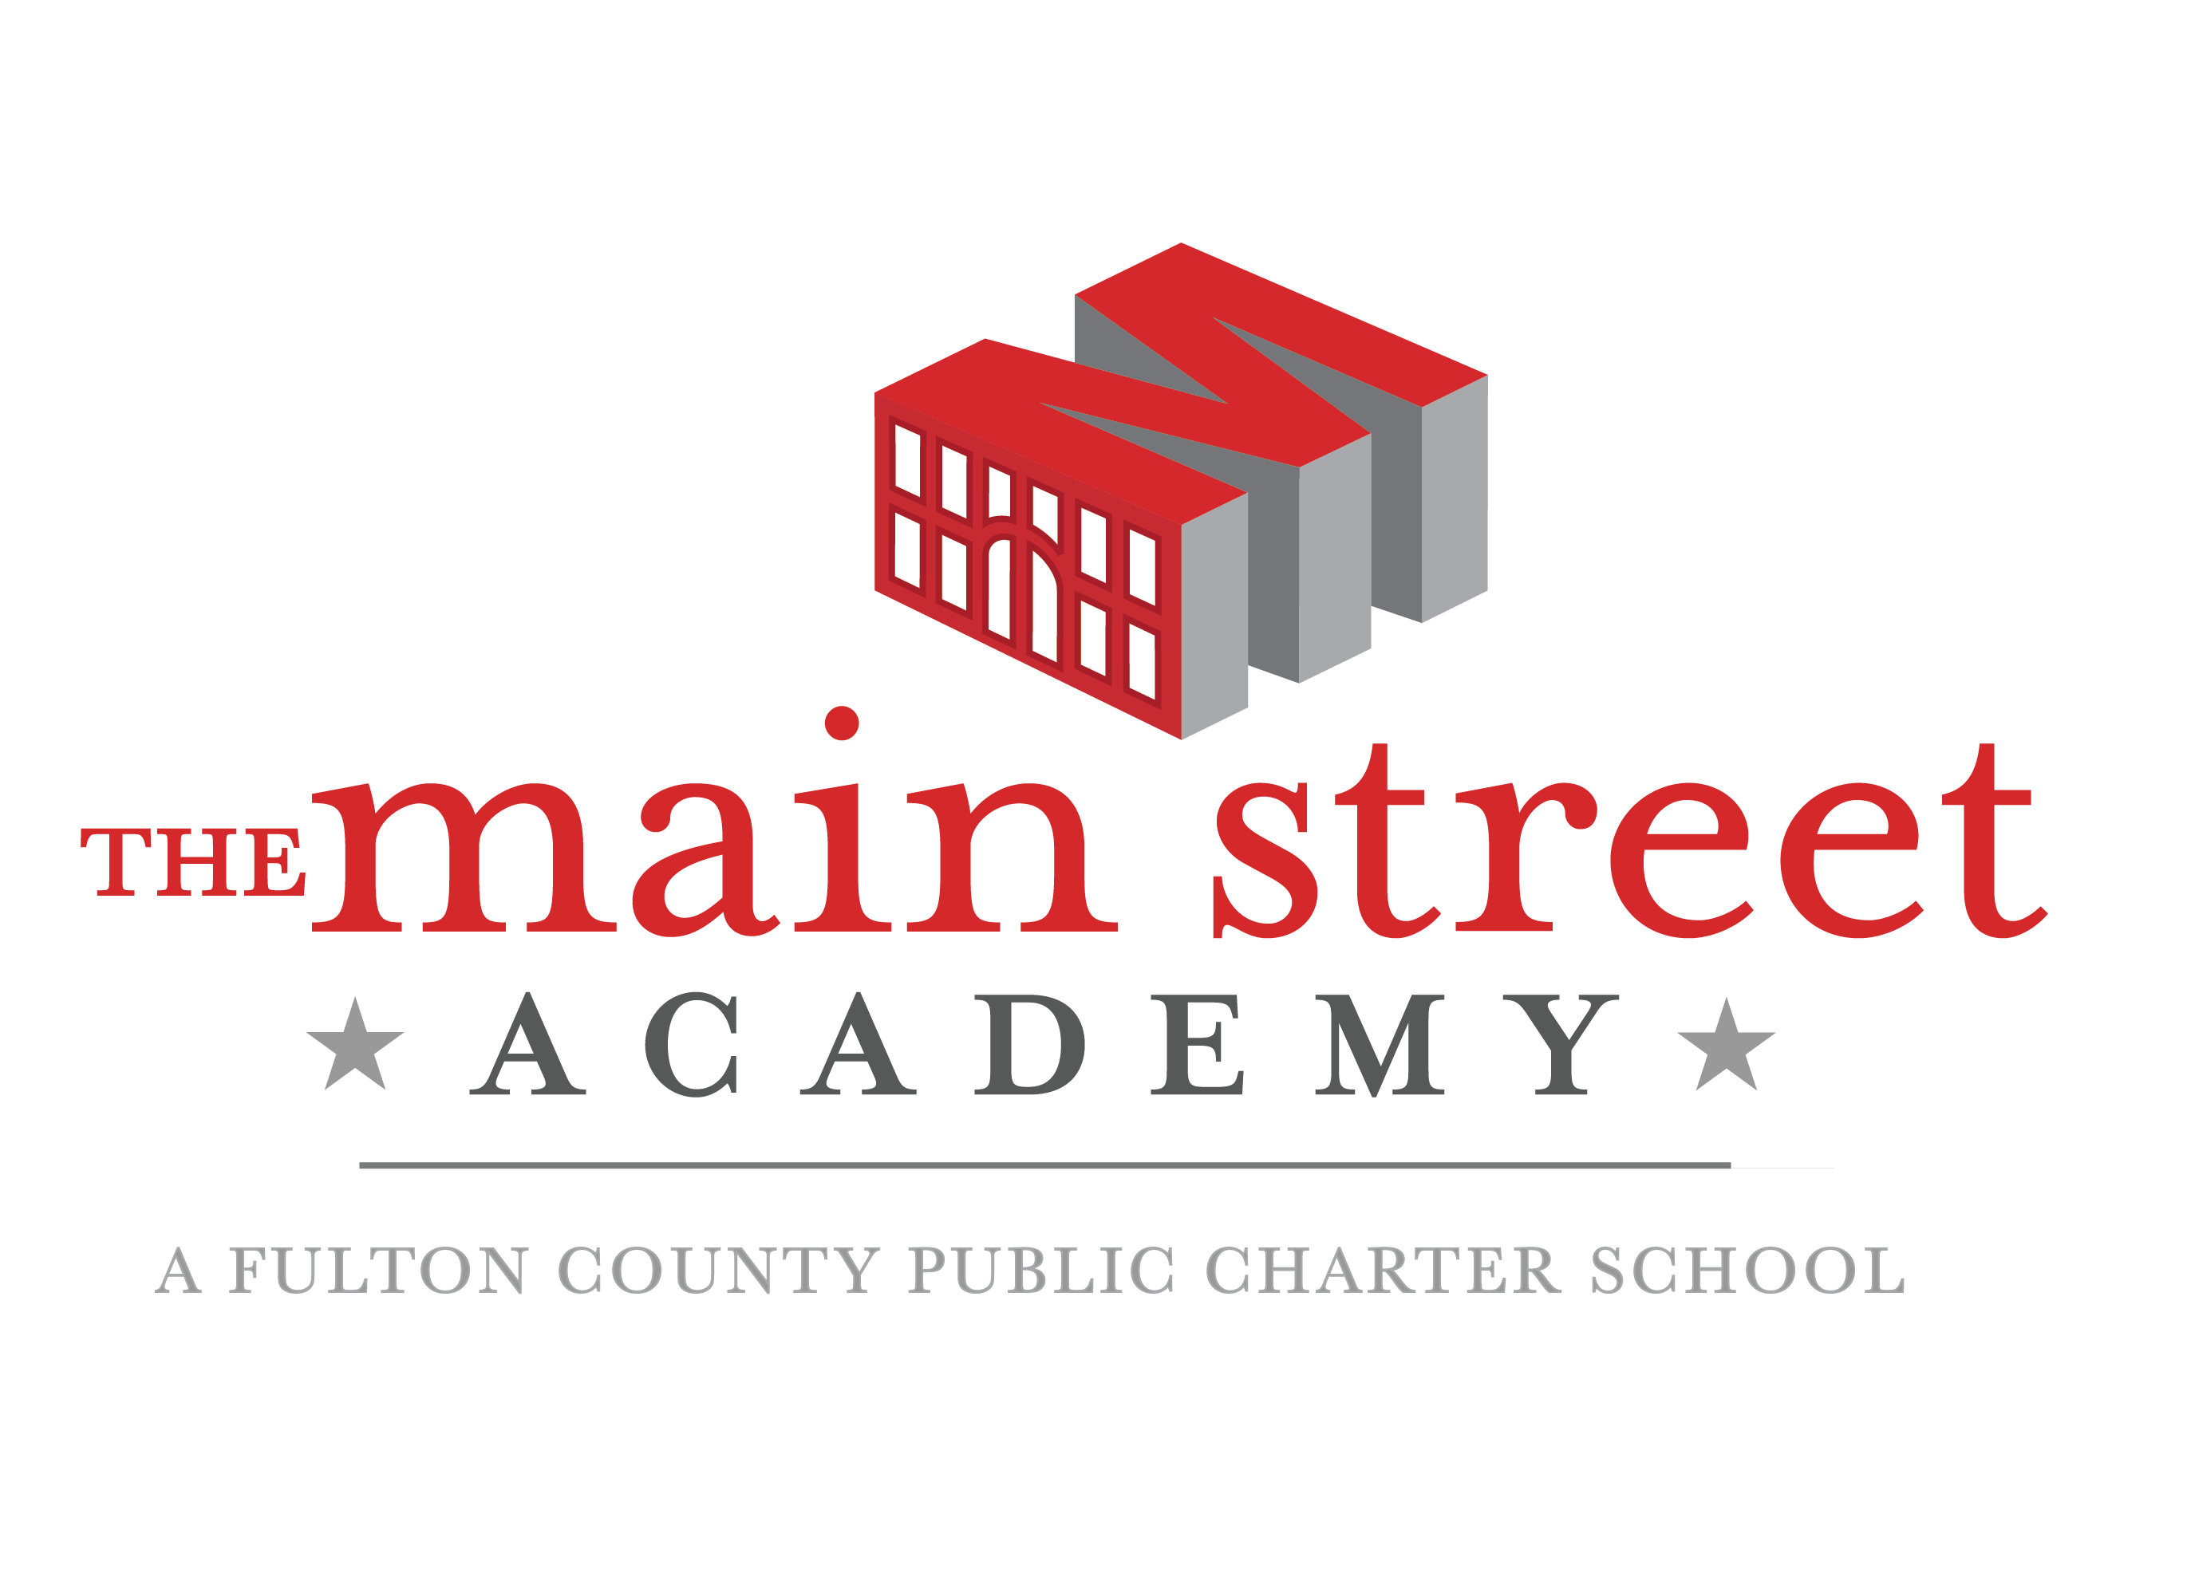
2861 Lakeshore Drive
College Park, Georgia 30337

Strategic Plan
2016 – 2019

Updated on 1/28/17
Updated on 1/13/18
Updated on 2/27/18

Adopted by the TMSA Governing Board on:

Facilitated and Developed by:
www.gacharters.org
Table of Contents

 | The Main Street Academy  - Mission, Vision and Key Elements  - History of The Main Street Academy | Page 3
 | Strategic Planning  - Overview and Purpose  - The Planning Team  - Methodology  - Environmental Scan | Page 5
- III. | Strategic Initiatives  - Overview of Initiatives  - Detailed Goals, Measures, Action Steps | Page 16
- IV. | Monitoring  - Monitoring Schedule | Page 23

- The Main Street Academy (TMSA)

Mission, Vision and Key Elements

Mission (charter contract version)

The mission of TMSA is to offer all students a challenging and enriching education from a dedicated and student-focused staff in partnership with highly involved parents. Students will leave TMSA with high expectations of themselves as they prepare for further education and become contributing members of their diverse communities.

Innovative Features

TMSA shall implement a School-wide Enrichment Model that emphasizes instruction in the expressive arts, physical education, and foreign language; flexible learning groups; and extended school hours.

Core Values

TMSA is built on the Four Cornerstones™ of highly effective schools.
- Top Talent
- A Culture of Engagement and Aspiration
- Demanding Content and Customized Instruction
- Achievement-Driven Management

History of TMSA

TMSA opened its doors in August 2010, after years of planning among a group of concerned parents and community members in the College Park community. The desire of TMSA’s founders was to create a high quality school of choice for families in College Park, East Point, Hapeville as well as surrounding south Fulton Communities.
At TMSA, all students receive a challenging and enriching education from a dedicated and student-focused staff in partnership with highly involved parents. Students leave TMSA with high expectations of themselves as they prepare for further education and become contributing members of their diverse communities.
TMSA offers families a school choice where all stakeholders work together to create an environment of academic excellence. TMSA began to build its reputation in the community from the start, as a home to remarkably high parental involvement. This was achieved via the Parent-Teacher Organization (PTO) and a system of Room Parents that extended support directly to classroom teachers. Parents commit to certain levels of volunteer commitment annually, which typically results in more than 12,000 volunteer hours annually.
While other public schools scaled back on their commitment to the arts, TMSA has taken another path, with two art teachers and two music teachers. The result has been an outstanding band and chorus consisting of well over 100 students that perform regularly, as well as an annual art show. The school also features a robust extracurricular program, including robotics club, chess club, debate club, basketball, cheerleading and more.
TMSA has focused on community partnerships from the start, which has resulted in Marriott’s sponsorship of the school’s major annual fundraiser, the Tri-Cities 5K/10K, which draws hundreds of runners from the area to certified competition. The annual silent auction recently had its most successful event yet, bolstered by contributions from more than 200 local businesses. The fall festival is another annual event displaying a great deal of community support and partnerships.
The academic program at TMSA flourished in spite of significant facility challenges that are not uncommon in the charter sector. The school’s governing board has always represented a diverse, skilled and passionately focused cross-section of community members and parents. The board’s trademark continues to be an ability to achieve its fiduciary and academic achievement goals in a cohesive manner.
During its fifth year, TMSA earned accreditation through Advanc-ED. TMSA was also successful in its renewal petition to Fulton County, achieving charter renewal for five years. The campus was split between two churches and standalone modular structures for the first charter term. In 2015, TMSA closed on the purchase of the former Harriet Tubman Elementary school building, located at 2861 Lake Shore Drive, and occupied the building to begin its sixth year of operations.

- Strategic Planning

Overview and Purpose
At the beginning of the 2015-2016 school year, TMSA’s governing board agreed to develop a strategic plan aligned with the term of TMSA’s renewed five-year charter. The strategic planning process formally began on January 9, 2016. The Georgia Charter Schools Association (GCSA) was engaged to facilitate the process and develop the strategic plan. The strategic planning process used by GCSA was designed to comply with the State Board of Education (SBOE) Standards for Effective Governance of Georgia Nonprofit Charter School Governing Boards, adopted in November 2014, as well as the National Association of Charter School Authorizers strategic planning framework for charter schools.

Some of the key strategic level issues that needed to be addressed through this process were: program growth, continued implementation of the academic program, board development, resource development, family and staff recruitment, retention and training, and fiscal health.

The strategic plan is meant to guide decision-making and implementation throughout the remainder of the 2015-2020 charter term. It is also intended to guide the planning for charter renewal, which is submitted during or after year four of the current term.

The Planning Team
The strategic planning team included most members of TMSA’s governing board, the principal, and a selection of school staff. The efforts of the strategic planning team were valued and appreciated. The following individuals served on the strategic planning team:

Board Members | Staff Members
Arnolie, Juanita | Parker, Cheryl (Interim Principal)
Baker, Robert (Chair) | Smith, Virginia (Dir. School Operations)
Bennett, Jenny | Robinette Jr., Michael (Teacher)
Dolby, Kia
Mayeske, Noel
Miranda, Solimar
Morrison, Tony (Treasurer)
Motley Broom, Bianca (Secretary)
Pickett, PhD., De’Andre
Reimels, Beth
Rodgers, Erin
Strabo, Kevin

2018 Planning Team

January 13, 2018 Session:
Bateman, Britton
Brown, Farrah
Dearolph, Rebecca
Fine, Jennifer
Jackson-Lee, Laurie
Johnson, Kelly
Parham, Frederick
Pickett, Dr. DeAndre
Rodgers, Erin
Vin, Tha

February 27, 2018 Session:
Bateman, Britton
Dearolph, Rebecca
Pickett, Dr. DeAndre
Rodgers, Erin
Vin, Tha

Methodology
Planning Session I
On January 9, 2016, GCSA facilitated a “Strategic Planning Workshop”. The purpose of this session was to establish conceptually what the strategic planning process requires in terms of perspective, analysis and thought process. Key concepts were reviewed and discussed to assist the group in gaining some perspective on how to approach the process to achieve the desired outcome: a strategic plan guiding the school through year five and beyond. A strategic framework was also provided that outlined the following elements:

- Vision
- Mission
- Strategic Initiatives
- Strategic Goals
- Tactical Plans and Measurements

The following steps were agreed upon (for planning sessions I, II, and implementation phase):

- Conduct visioning exercise
- Create an environmental scan of members’ collective knowledge
- Identify vision (external and internal)
- Identify strategic initiatives
- Work on goals
- Develop tactical plans to accomplish goals
- Review drafted plan and provide feedback
- Approve strategic plan formally at a regular board meeting
- Monitor plan on a quarterly basis

Planning Session II
The second planning session was conducted on March 5, 2016. At that time, the following planning tasks were completed:

- Worked collaboratively to develop goals, timelines, resources needed, and assign responsibility
- Developed measures to determine goal attainment

Planning Session III
A third planning session was conducted for March 31, 2016. At that time, the following planning tasks will be completed:

- Presentation of strategic plan
- Review of stakeholder feedback
- Strategic plan edits

Draft Review Period
The strategic planning team will have two opportunities to review the strategic plan prior to the pre-final version being presented to the board for approval:

- March 28, 2016, draft one
- April 19, 2016, draft two

Members of the strategic planning team will provide substantive feedback.

Environmental Scan

Visioning

The governing board and leadership were asked to imagine TMSA in ten years.

The following are key descriptive elements that resulted from the visioning exercise. (Items are in alphabetical order):

- 21st Century Program
- Academic and athletic facility
- Alumni involvement
- Career path awareness for students
- Cash reserve
- Challenging curriculum
- Community engaged (including financial support)
- Community involvement at all levels
- Diverse (staff, students)*
- Diverse educational perspective and methods / cultural competency*
- Fiscally sound*
- Grades K-12
- Growing leaders
- Improved student and teacher retention*
- Improved student performance exceeding Fulton County and the state*
- Innovative methodologies
- Meet and exceed standards
- Model for other charters in terms of best practices
- Nurturing
- Operationally advanced
- School of choice
- Smooth, effective governance
- State-of-the-art technology
- Stellar board and leadership
- Strong leadership
- Student-centered
- Students prepared for high school and beyond
- Top teachers and staff
- Well respected – expert

*These items were mentioned more than five times.

TMSA’s Identity
Another activity was used to gather information about the team’s understanding of TMSA’s identity. The following terms and phrases resulted from the discussion.

- Alternative to traditional public school
- Better than public options, not better than all private school options
- Community doesn’t know about the new location
- Good fine arts program
- Good parental involvement
- Good relationship with Fulton County Schools
- Good teachers
- Good use of existing resources
- Grades 6-8 achievement is not as strong as elementary
- Increasing awareness
- K-5 program is known as quality
- Lack of diversity at student and staff levels
- Lack of technology
- Misperceptions about the school (Who are the stakeholders, how does a charter function?)
- Need clearer expectations for staff
- Need to have a “story”
- Not enough student exposure to technology
- Professional development image can use improvement
- Robotics program is a positive
- Shedding early challenges
- Tension with local neighbors

SWOT Analysis
Environmental scan activities were conducted by using variations on a SWOT analysis tool. Internal and external Strengths, Weaknesses, Opportunities and Threats were discussed, identified and analyzed. The following themes were identified from information gathered during the environmental scan activities and contain perceptions of both internal and external conditions.

The first environmental scan activity focused on the governing board’s, and the leadership team’s, general knowledge about conditions impacting the school. The following chart demonstrates the present knowledge about external conditions that impact the market place for TMSA:

The Marketplace –
Working as a group, the following essential question was discussed and analyzed:

What do we understand about the conditions in the external setting and what do we understand about our organization?

The group was specifically asked to list the key opportunities and threats that may impact TMSA’s ability to shape the educational landscape in Georgia. The following categories were considered as a guide:

Our Organization
Working in two groups, each group consisting of board members and members of the school’s leadership team, the SWOT analysis was conducted to identify the following:

- Internal strengths and weaknesses:

SWOT – A granular perspective:
The following information provides a closer look at internal strengths and weaknesses. The following essential questions provided the framework for the discussion.

- The organization’s primary programmatic, operational, and administrative strengths and weaknesses.

Collective Visioning
At the end of the first strategic planning session, prior to establishing preliminary strategic initiatives, the group was asked to imagine TMSA ten years from now in terms of governance, fiscal viability, and academic achievement:

TMSA’s governing board is a model of transparency and integrity that has built a school with significant financial reserves and a stable, well-cared-for facility. The high-functioning board has secured outside resources to augment a challenging curriculum and a rich SEM Cluster program that celebrates intellectual curiosity and connections to the world outside the school walls. The governing board recognizes TMSA’s diversity and fosters investigation, understanding, and celebration of different peoples and cultures. TMSA recognizes that standardized tests are not the only measure of student learning, but nonetheless regularly outperforms county and state schools on nationally normed tests.

Authorizer Expectations
In order to establish a high quality charter school all stakeholders, particularly the governing board and leadership team, must fully understand authorizer expectations. The following list of expectations was used to guide the SWOT and visioning discussions:

- TMSA Strategic Plan Initiatives

Overview of Initiatives and Goals

- Initiative I: Resource Development
  - Goal 1: Board will identify grant and other resource development opportunities.
  - Goal 2: Establish partnerships with larger corporations such as Delta, Porsche, Chik-fil-A, etc., to provide financial, in-kind support and services.
  - Goal 3: Develop a minimum financial reserve of three to six months operating expenses.

- Initiative II: Teacher Development
  - Goal 1: Implement a teacher mentoring and induction program.
  - Goal 2: Create a professional development plan for teachers.
  - Goal 3: Brand TMSA as a “Best Places to Work” organization.

- Initiative III: Technology
  - Goal 1: Audit current technology equipment and infrastructure.
  - Goal 2: Investigate cutting edge educational technology and develop a wish list.

- Initiative IV: Curricular Enhancement
  - Goal 1: Implementation of a School Wide Enrichment (SEM) model.
  - Goal 2: Continued implementation and evaluation of Flexible Learning Groups (FLGs)
  - Goal 3: Increase kinesthetic learning and physical activity for all students.
  - Goal 4: Set standards for excellence for student achievement.
  - Goal 5: Develop outdoor classroom space.

- Initiative V: Student Safety
  - Goal 1: Develop a secondary entrance / exit / evacuation route.
  - Goal 2: Seal off or reconfigure basement.
  - Goal 3: Assess playground and green space safety and determine needed safety improvements.
  - Goal 4: Refurbish and improve athletic fields and structures.
  - Goal 5: Provide adequate coverage, lighting, and heating for carline drop-off area.

Key -

 | Completed
Strikethrough | Deleted

  - Strategic Initiative I: Resource Development

Goal | Due Date | Action Item | Person/Team Responsible | Status / Completed | Notes
1. Board will identify grant and other resource development opportunities | On going | Develop RFPs for facilities projects | Virginia Smith | In Progress
 | 6/30/18 | Identify contractor to execute grant proposals | Finance Committee | In Progress

Goal | Due Date | Action Item | Person/Team Responsible | Status / Completed | Notes
2. Establish partnerships with larger corporations such as Delta, Porsche, Chik-fil-A, etc. to provide financial, in-kind support and services | 6/30/18 | Establish partnership task force (linked to finance committee) | Kelly Johnson (Delta) | In Progress (early stages) | Establish branding initiatives before pursuing partnerships
 | 6/30/18 | Determine in-kind and support service needs | Erin Rodgers (Survey Monkey) | In Progress
 | 6/30/18 | Determine list of local business partners and opportunities for partners (advertising) | NEED INPUT HERE | Not started | Need to develop a standard MOU to document partnerships
 | On going | Mandatory survey for parents w/ enrollment packet to determine parent & family networks that might lead to resources for the school | Virginia Smith - Enrollment packet  Erin Rodgers - Survey | On Going | need to update survey and ensure inclusion of survey with current enrollment packets
 | 6/30/18 | Update list of local business partners and opportunities for partners (advertising) | Erin Rodgers, Kristin Jackson | In Progress
 | 6/30/18 | Create fundraising task force | Finance Committee, Communications Committee | Not started | needs to be aligned with communications committee
 | 6/30/18 | Hold a discovery session with parents to determine needs for communications / fundraising) | Communications Committee | In Progress

Goal | Due Date | Action Item | Person/Team Responsible | Status / Completed | Notes
3. Develop a minimum financial reserve of three to six months of operating expenses | 6/30/16 | Increase grant revenue  Improve FTE reporting  Increase fiscal controls  Eliminate debt to Edison Learning  Cessation of lease payments | Virginia Smith, Finance Committee | Completed | Currently have 3-4 months in reserve

Parking Lot:
- Develop campaign/collateral materials that communicate funding needs
- Codify the difference between parent-based fundraising and resource development.
- Create a doc (maybe policy) on how resource development happens at TMSA
- Contemplate the establishment of a separate foundation for resource development
- Establish branding initiatives before pursing partnerships

  - Strategic Initiative II: Teacher Development

Goal | Due Date | Action Item | Person/Team Responsible | Status / Completed | Notes
1. Implement a teacher mentoring and induction program | On going | Update board on staff retention rate | Cheryl Parker | In Progress | Quarterly at least
 | 6/30/18 | Update board on Human Resource cycle, including induction / orientation of new hires | Virginia Smith | Not started
 | 6/30/18 | Review and report faculty survey data | Fred Parham | In Progress | Need to get baseline data
 | 7/1/18 | Establish check points for new hires to ensure they are set up for success at TMSA | Principal Parker, ASPC | Not started
 | 6/30/18 | Determine if time can be built in for induction activities for new teachers | Principal Parker, ASPC | Not started
 | 12/1/18 | Develop an on-going teacher support mechanism | ASPC | In Progress | I recommend striking this and asking for updates on this from Ms. Parker
 | 6/30/18 | Establish baseline for staff retention goals | Cheryl Parker, Virginia Smith | In Progress
 | 6/30/18 | Codify exit interview process for faculty and staff | Virginia Smith, Cheryl Parker, ASPC (policy level only) | Not started

Goal | Due Date | Action Item | Person/Team Responsible | Status / Completed | Notes
2. Brand TMSA as a Best Places to Work organization | TBD | Research "best places to work" initiatives | TBD | Not started | Working on bringing in outside agency to execute
 | TBD | Play up current strengths, related to workplace satisfaction: develop talking points | Communications Committee | In Progress
 | 6/30/18 | Improve career opportunities section of the website for future employees by highlighting benefits | Communications Committee | In Progress
 | TBD | Review teacher salary scale | Finance Committee, Virginia Smith | Not started
 | On going | Maintain "best practices" designation | Communications Committee, Finance Committee, ASPC | On going

Parking Lot:
- After receiving update on HR cycle, determine additional strategic actions needed regarding the induction and mentoring of new teachers
- Elisa's note: based on our recent work, I recommend letting this work remain at the operational level and the board focus on any related policies as well as systematic updates (2x year or quarterly) on HR cycle, staff satisfaction, etc..

  - Strategic Initiative III: Technology

Goal | Due Date | Action Item | Person/Team Responsible | Status / Completed | Notes
1. Audit current technology equipment and infrastructure | 6/30/18 | Present updated technology plan to the board | Kiet - Technology Manager | Not started

Parking Lot:
- Erin will check with Noel on status of former Goal 2: "investigate cutting edge educational technology and develop a wish list"

  - Strategic Initiative IV: Curricular Enhancement

Goal | Due Date | Action Item | Person/Team Responsible | Status / Completed | Notes
1. Implementation of School Wide Enrichment (SEM) | 6/30/18 | Update board on SEM-school-wide classroom implementation against charter goals | Marlon Tempro | Not started | SEM actions completed in strategic plan

Goal | Due Date | Action Item | Person/Team Responsible | Status / Completed | Notes
2. Continued implementation and evaluation of Flexible Learning Groups (FLGs) | 6/30/18 | Report quarterly to board on impact of FLGs | ASPC | On going | Verify % of units in math classes (grades 2-5)

Goal | Due Date | Action Item | Person/Team Responsible | Status / Completed | Notes
3. Increase kinesthetic learning and physical activity for all students | 6/30/18 | Assess funds from silent auction for possible P.E. enhancements | Finance Committee, Cheryl Parker | On going
 | On going | Update board quarterly on daily brain breaks / recess | Cheryl Parker | On going
 | On going | Update board quarterly on P.E. scheduling | Cheryl Parker | On going | From 1-2x week to 2-3x per week

Goal | Due Date | Action Item | Person/Team Responsible | Status / Completed | Notes
4. Set standards of excellence for student achievement | 6/30/18 | Revisit uniform policy | Governance Committee | Not started

Parking Lot:
- Future goal - determine if academic improvement can be tied to increased exposure to kinesthetic activities

  - Strategic Initiative V: Student Safety

Note:
- All goal 5 actions completed

- Monitoring

Recommended Monitoring Cycle

In order to successfully execute the action and attain the goals set forth in this plan, consistent and timely monitoring must be conducted. It is recommended that the plan be monitored on at least a quarterly basis. It is recommended that the plan be monitored on at least a quarterly basis.

