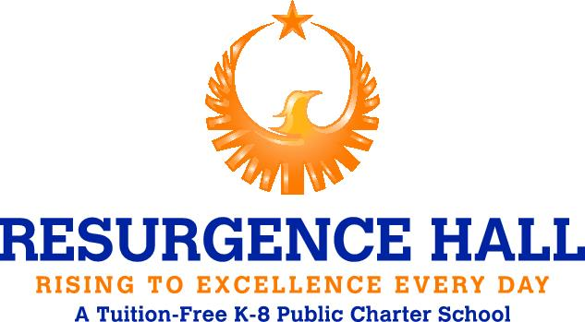

MEDIA RELEASE FORM

I, ____________________________, give permission for Resurgence Hall staff to record, film, photograph, interview, and/or publicly exhibit, display, distribute or publish my child’s name, appearance and spoken words for Resurgence Hall promotional purposes, whether undertaken by school staff, students, or anyone outside the school, including the media. I agree that the school may use, or allow others to use, those works without limitation or compensation. I release Resurgence Hall Charter School staff from any claims arising out of my appearance or participation in these works.

This authorization is in effect for the duration of your scholar’s enrollment until written withdrawal of authorization is provided to the school.

Please sign and return to the Manager of Operations.

_________________________________
Scholar Name (Full)

_________________________________
Parent/Guardian Name

_________________________________
Parent/Guardian Signature

_________________________________
Date

