Governance Committee Report for the April 25, 2022 Board Meeting

Governance Committee Members: Maurice Baker, Howard Grant, Walt Higgins, Rewa Berry (Vice-Chair), Stephanie Hodges, Panya Lei Yarber-King (Chair)

Status Updates
- Board Training
  - All board members have been registered for the digital governance series.
  - Every board member should have an email from Instructure Canvas. Start your training today! Aim to complete by June 17, 2022.
  - Board Boosts – This is an option for training as well.
  - Whole Board Governance training – April 25th Board meeting
  - Training tracker has been updated. Please validate:
https://docs.google.com/spreadsheets/d/14qN_MRiZtDWhh-eOYIZWrRHGQyufwQOyt8Il6FZbiJA/edit#gid=1490980322
- Strategic Plan – Ms. Lamar/Ms. Hodges – No update.
- Board Giving Update
  - Giving participation is 100%.
  - Giving link: https://centennialacademy.networkforgood.com/projects/138117-centennial-academy-hero-fund
- Board Engagement - TBD
- Update Conflict of Interest Disclosures – Rewa Berry – No update.
- Board member commitments – Rewa Berry – April Board meeting.
- Evaluate and Assess Board/Forms – Rewa Berry – April Board meeting.
- New Board Member Onboarding
- Dashboard – Drafted

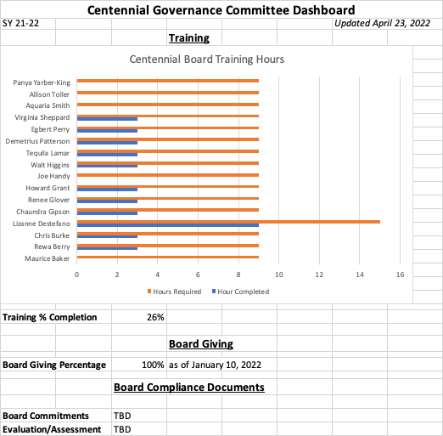

- Meetings
  - The last governance committee meeting was April 22, 2022.
      - Training
        - Training for April board meeting
          - Best practices in board engagement
          - Difference between board governance and operations/when does the board weigh in
        - Aim to complete training requirements by June 17
        - GCSA
      - Board Assessments/JD
        - Rewa will present
        - Will utilize DocuSign
      - Conflict of Interest and Code of Ethics planned for fall
      - Dashboard
      - Board slate
        - Brought to June meeting last year
        - Vote was at the retreat
        - Possible candidate for a committee
  - Committee meetings
    - Governance Committee meetings are on the 4th Fridays of each month (held virtually via Zoom due to COVID-19).
    - The next Governance Committee meeting is Friday, April 22, 2022 at 12 noon.
    - Next meeting agenda:
      - Committee work plan
        - Board commitments
        - Evaluate and assess board
      - Dashboard
      - New board member pipeline
      - Board onboarding
      - Board training
      - Policy manual – Dr. Grant will facilitate review for 2021.
      - Board attendance/compliance

Governance Committee Role & Tasks
- Short-term
  - Develop a committee charter
  - Designate a Vice Chair
  - Confirm committee work plan and schedule
- Medium to Long-term
  - Monitor and maintain board-wide adherence to best practices
  - Conduct annual board and committees’ self-assessment
  - Periodically review board size, composition and profile
- Annually review by-laws
- Create calendar of cyclical board decisions
- Monitor board member performance relative to board commitment letters
- Develop Strategic Plan
- Align Governance Committee description to the strategic plan and ask all committees to do the same
- Develop short and long-term succession planning
- Recruit demographic and skills diversity among board members, including race, gender, age, skill set, perspective and experience
- Track board term expirations
- Support the board chair in designing and executing annual board goal-setting process
- Identify governance committee goals and track progress
- Recruit, onboard and train new board members
- Develop required Board Policies – Code of Ethics, Conflict of Interest (including Annual Disclosure) and Grievance, and ensure compliance
- Ensure compliance with the Charter Contract and the Petition
- Confirm the specific tasks of the Committee

